**DOMAIN: Applied data science**

**PROJECT TITLE: Air Q Assessment TN**

**PROBLEM STATEMENT:**

The objective of this project is to analyze and visualize air quality data from various monitoring stations in Tamil Nadu. The dataset contains measurements of Sulfur Dioxide (SO2), Nitrogen Dioxide (NO2), and Respirable Suspended Particulate Matter/Particulate Matter 10 (RSPM/PM10) levels in different cities, towns, villages, and areas. The project aims to gain insights into the air pollution trends, identify areas with high pollution levels, and create a predictive model to estimate RSPM/PM10 levels based on SO2 and NO2 levels.

**PROBLEM DEFINITION:**

The project aims to analyze and visualize air quality data from monitoring stations in Tamil Nadu. The objective is to gain insights into air pollution trends, identify areas with high pollution levels, and develop a predictive model to estimate RSPM/PM10 levels based on SO2 and NO2 levels. This project involves defining objectives, designing the analysis approach, selecting visualization techniques, and creating a predictive model using Python and relevant libraries.

**1. Define Objectives:** Clearly outline your project's objectives, which include analyzing air pollution trends, identifying high-pollution areas, and creating a predictive model for RSPM/PM10 levels.

**2. Data Collection:** Gather air quality data from monitoring stations in Tamil Nadu. Ensure the data is reliable and covers a sufficient time period.

**3. Data Preprocessing:** Clean and preprocess the data, handling missing values and outliers, and preparing it for analysis.

**4. Exploratory Data Analysis (EDA):** Use Python libraries like Pandas, Matplotlib, and Seaborn to explore the data. Visualize pollution trends, correlations between variables, and identify high-pollution areas.

**5. Feature Engineering:** Create relevant features, and if needed, transform data to improve model performance.

**DESIGN THINKING:**

**Project Objectives:** Define objectives such as analyzing air quality trends, identifying pollution hotspots, and building a predictive model for RSPM/PM10 levels.

Analysis Approach: Plan the steps to load, preprocess, analyze, and visualize the air quality data.

Visualization Selection: Determine visualization techniques (e.g., line charts, heatmaps) to effectively represent air quality trends and pollution level.

**Design thinking can be a valuable approach when conducting an air quality assessment project.**

**1. Empathize with Stakeholders:**

- Understand the concerns and needs of stakeholders, such as local residents, environmental agencies, and policymakers. Conduct interviews or surveys to gather their perspectives on air quality issues.

**2. Define the Problem:**

- Clearly define the problem you're addressing in the context of air quality. This could be the impact of pollution on public health, identifying pollution sources, or predicting future air quality trends.

**3. Ideate Solutions:**

- Brainstorm potential solutions and strategies for improving air quality based on your problem definition. Encourage creative thinking and consider both technical and non-technical solutions.

**4. Prototype and Test:**

- Develop prototypes or models of your proposed solutions. For example, you could create a prototype of a mobile app that provides real-time air quality information or a data visualization tool. Test these prototypes with end-users to gather feedback.

**5. Iterate and Refine:**

- Based on user feedback, iterate and refine your prototypes and solutions. Continuously improve your models and tools to make them more effective and user-friendly.

**6. Collaborate:**

- Collaborate with experts in the field of air quality, environmental science, and data analysis to ensure that your solutions are scientifically sound and practical.

**7. User-Centered Approach:**

- Keep the end-users in mind throughout the project. Ensure that your solutions are user-centered and address the specific needs and preferences of the people who will benefit from them.

**8. Visual Storytelling:**

- Use storytelling techniques and visualization to communicate your findings effectively. Create compelling narratives that convey the impact of air quality on people's lives and the potential benefits of your solutions.

**9. Feedback Loops:**

- Establish feedback loops with stakeholders and the community to gather ongoing input and make adjustments as needed. This ensures that your project remains responsive to evolving needs and challenges.

**10. Sustainability:**

- Consider the long-term sustainability of your solutions. How can they be maintained and scaled over time to have a lasting impact on air quality?

By integrating design thinking into your air quality assessment project, you can create more user-friendly and effective solutions that address the real needs of the community and contribute to improving air quality in Tamil Nadu.

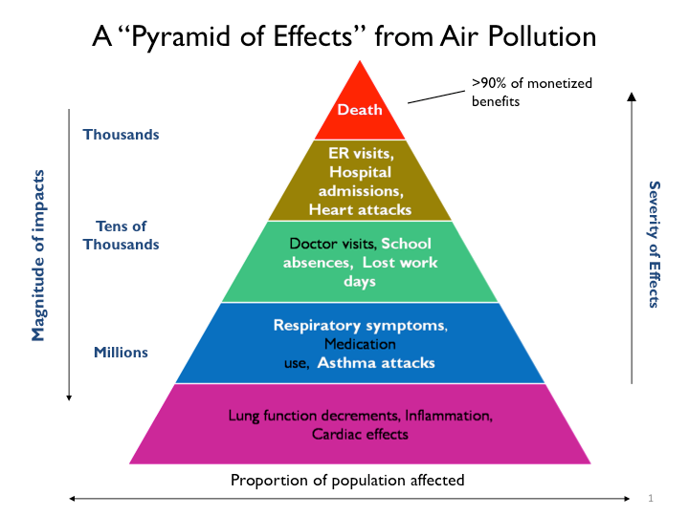

<https://images.app.goo.gl/42Ui6o75vvzjp5b29>

This image from an Tn.gov

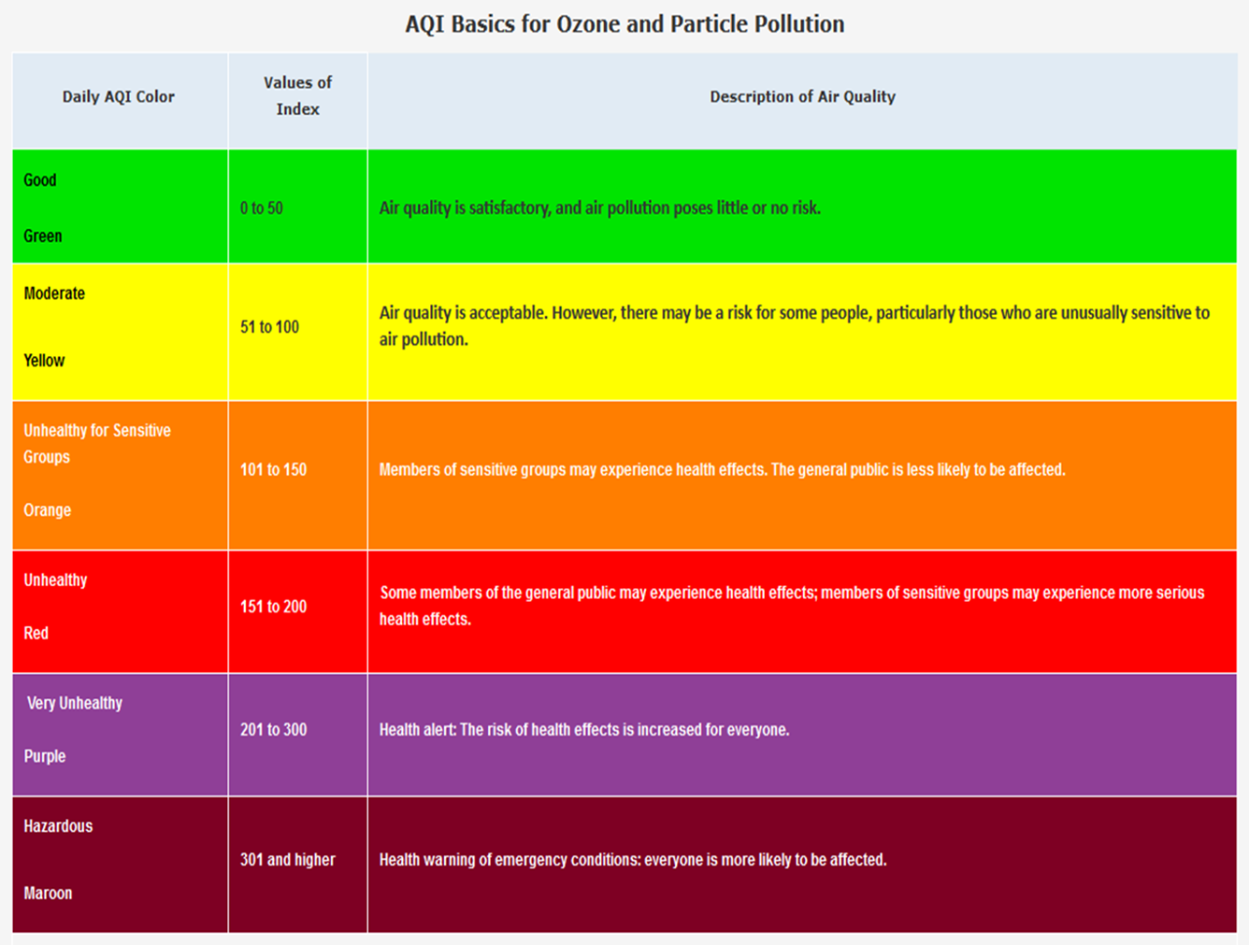

<https://www.tn.gov/health/cedep/environmental/environmental-health-topics/eht/air-quality.html>

**Conclusion:**

This document outlines our understanding of the problem and our approach to solving it. The success of this project hinges on robust data collection, effective preprocessing, and the selection and training of suitable predictive models. By following a design thinking approach, we aim to create a valuable tool that empowers investors with reliable stock price predictions, ultimately assisting them in making informed investment decisions.